What is cloud ?
What is cloud computing and how does it work?
Cloud computing is a network of servers connected using the Internet. Its main function is to share information, resources, and software. The Internet acts as the invisible cable that connects everything. This includes all physical and virtual servers all over the globe.

The main purpose of cloud computing is to give access to data centers to many users. Users can also access data from a remote server. Examples of Cloud Computing Services: AWS, Azure, Google Cloud

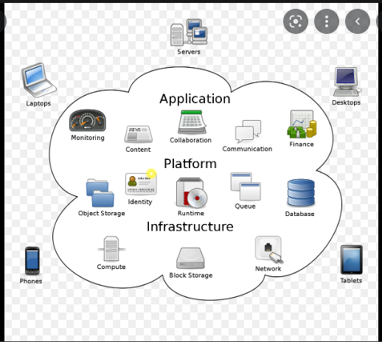
There are 3 types of cloud computing:
Infrastructure as a Service (IaaS): This would be the actual data storage – instead of maintaining servers and physical data centres, you can access all your data seamlessly though the cloud.
Platform as a Service (PaaS): A service provider delivers a platform to you, enabling you to develop, run, and manage business applications over the cloud.
Software as a Service (SaaS) : This would be a software application that you could access over the cloud without having to have it installed on your device.
SaaS services include Dropbox, Salesforce, Cisco WebEx.
PaaS services include Google App Engine, Apache Stratos and OpenShift.
IaaS services are Amazon Web Services (AWS), Cisco Metapod and Microsoft Azure.
With IaaS, companies control their own computing, networking, and storing components without having to manage them on-premises physically
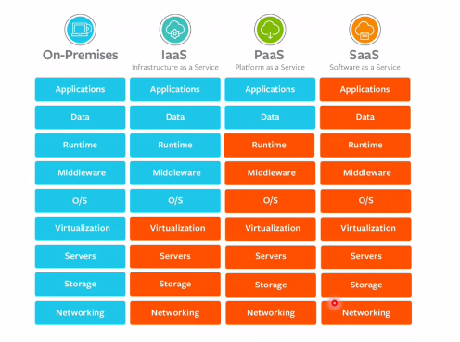
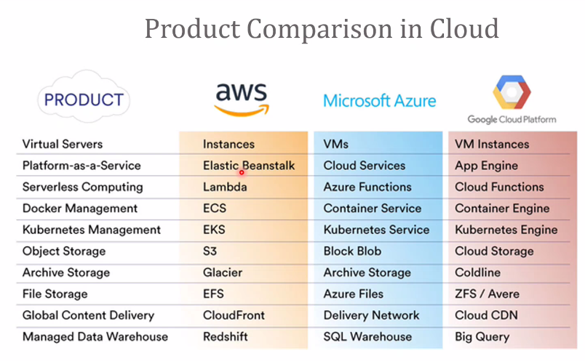

What is AWS ?
AWS stands for Amazon Web Service; it is a collection of remote computing services also known as a cloud computing platform. This new realm of cloud computing is also known as IaaS or Infrastructure as a Service. It is simply can say “PAY As You Use”
AWS (Amazon Web Services) is a platform to provide secure cloud services, database storage, offerings to compute power, content delivery, and other services to help business level and develop.

What is AMI?
AMI stands for Amazon Machine Image. It’s a template that provides the information (an operating system, an application server, and applications) required to launch an instance, which is a copy of the AMI running as a virtual server in the cloud. You can launch instances from as many different AMIs as you need.
- Identity and Access Management: It provides enhanced security and identity management for your AWS account
- Simple Storage Device or (S3): It is a storage device and the most widely used AWS service
- Elastic Compute Cloud (EC2): It provides on-demand computing resources for hosting applications. It is handy in case of unpredictable workloads
- Elastic Block Store (EBS): It offers persistent storage volumes that attach to EC2 to allow you to persist data past the lifespan of a single Amazon EC2 instance
- CloudWatch: To monitor AWS resources, It allows administrators to view and collect keys. Also, one can set a notification alarm in case of trouble.

DevOps Model Defined
DevOps is the combination of cultural philosophies, practices, and tools that increases an organization’s ability to deliver applications and services at high velocity: evolving and improving products at a faster pace than organizations using traditional software development and infrastructure management processes. This speed enables organizations to better serve their customers and compete more effectively in the market.


How DevOps Works
Under a DevOps model, development and operations teams are no longer “siloed.” Sometimes, these two teams are merged into a single team where the engineers work across the entire application lifecycle, from development and test to deployment to operations, and develop a range of skills not limited to a single function.
In some DevOps models, quality assurance and security teams may also become more tightly integrated with development and operations and throughout the application lifecycle. When security is the focus of everyone on a DevOps team, this is sometimes referred to as DevSecOps.
These teams use practices to automate processes that historically have been manual and slow. They use a technology stack and tooling which help them operate and evolve applications quickly and reliably. These tools also help engineers independently accomplish tasks (for example, deploying code or provisioning infrastructure) that normally would have required help from other teams, and this further increases a team’s velocity.

What is Load balancer?
Load balancer is a service which uniformly distributes network traffic and workloads across multiple servers or cluster of servers. Load balancer in AWS increases the availability and fault tolerance of an application. AWS Elastic Load Balancer is the single point of contact to all the clients, they can be sent to the nearest geographic instance or the instance with the lowest latency.

